**INTI International College Penang School of Engineering and Technology**

**3+0 Bachelor of Science (Hons) in Computer Science, in collaboration with Coventry University, UK**

**3+0 Bachelor of Science (Hons) in Computing, in collaboration with Coventry University, UK**

**Coursework cover sheet**

**Section A - To be completed by the student**

|  |  |
| --- | --- |
| Full Name: Lim Ni Feih | |
| CU Student ID Number: 12672774 | |
| Semester:2 | |
| Session:  **April 2022** | |
| Lecturer:  **Nadhrah Abdul Hadi (nadhrah.abdulhadi@newinti.edu.my)** | |
| Module Code and Title:  **4067CEM Software Design** | |
| Assignment No. / Title:  **Continuous Assessment** | % of Module Mark:  **50** |
| Hand out Date:  **22nd April 2022** | Due Date:  **Task 1: 13 May 2022, by 11.59pm**  **Task 2: 1 July 2022, by 11.59pm**  **Task 3: 17 June 2022, by 11.59pm.**  **Task 4: 17 June 2022, by 11.59pm.**  **Task 5: 17 June 2022, by 11.59pm.** |
| Penalties: No late work will be accepted. If you are unable to submit coursework on time due to extenuating circumstances, you may be eligible for an extension. Please consult the lecturer. | |
| Declaration: I/we the undersigned confirm that I/we have read and agree to abide by the University regulations on plagiarism and cheating and Faculty coursework policies and procedures. I/we confirm that this piece of work is my/our own. I/we consent to appropriate storage of our work for plagiarism checking.  Signature(s): ____________LNF____________ | |

**Section B - To be completed by the module leader**

|  |  |  |
| --- | --- | --- |
| Intended learning outcomes assessed by this work:  1. Understand and apply appropriate concepts, tools and techniques to each stage of the software development  2. Understand and apply design patterns to software components in developing new software  3. Demonstrate an understanding of project planning and working to agreed deadlines, along with professional, interpersonal skills and effective communication required for software production  5. Demonstrate an awareness of, and ability to apply, social, professional, legal and ethical standards as documented in relevant laws and professional codes of conduct such as that of the Malaysian National Computer Confederation. | | |
| Marking scheme | Max | Mark |
| 1. User Story Mapping 2. Setting up a GitHub Repository 3. Creating a Class diagram and design pattern selection 4. Creating a Prototype User Interface and Usability Testing 5. Discuss the ethical issue related to the software | 20  10  30  20  20 |  |
| Total | 100 |  |

# Prototype User Interface of 2 Main Functions

The two main functions of the proposed system include sign-in and registration for events. Sign-in is one of the important functions in this system because the students have to sign in using their accounts to have the authority to access the system. Registering for events is also a main function of the system as the system’s main objective is to allow students to register for events in their college

The prototype user interface has been developed to suit the iPhone 13 Pro model.

## Sign-in UI

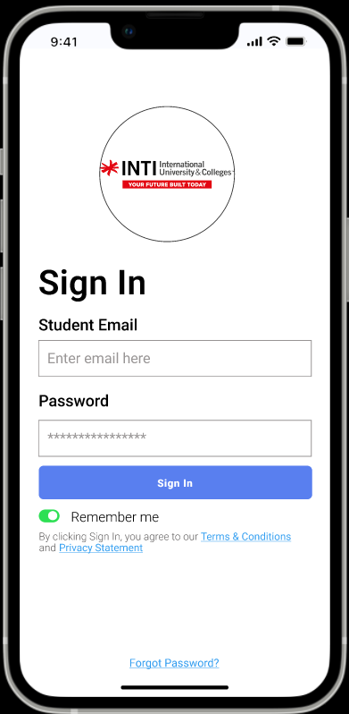

Figure 1

Figure 1 above shows the user interface for the sign-in function.

As per the figure, the logo of the college that the student is enrolled in will be displayed in the circle located at the top of the page. INTI International College Penang’s logo has been used to show as an example of the user interface.

The student can input their student email along with the password that has been set by the administration of his/her college. Then, the student can click on the Sign In button to sign in to the application.

The student has an option to activate the Remember me toggle so that the system remembers the student’s email and can auto-fill it in the next time the student signs in to the application on his/her device.

To read the terms and conditions or privacy policy of using the application, the student can tap on the underlined blue text “Terms & Conditions” or “Privacy Statement” respectively.

If the student forgot his/her password, he/she can tap on the forgot password to initiate the forgot password function which will lead to an overlay as shown in Figure 2 below. The student can tap on the black rectangle at the top of the overlay or swipe the overlay down to close the overlay and return to the sign in page.

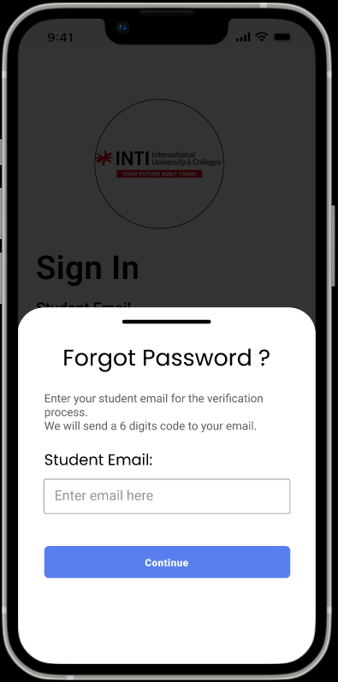

Figure 2

The student then enters the his/her student email into the text box and tap on the Continue button to receive a 6 digit code on his/her email.

The application will then swap the overlay to the 6 digit code overlay as shown in Figure 3 below.

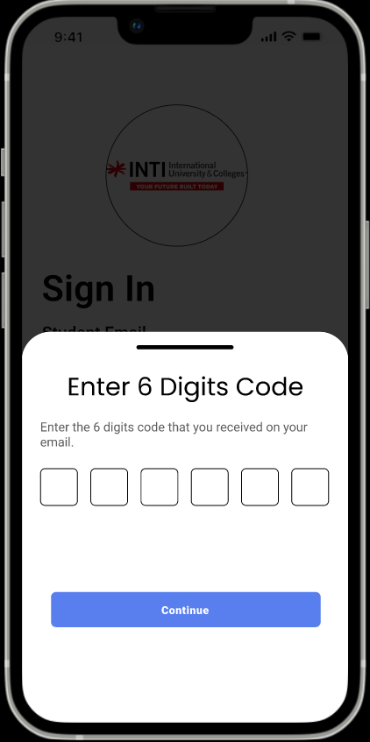

Figure 3

Here, the student will input the 6 digit code that has been sent to his/her email. Then, the student has to tap on the continue button to swap to the reset password overlay as shown in Figure 4.

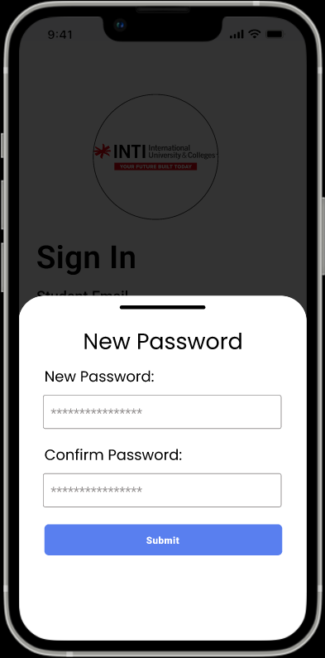

Figure 4

On this overlay, the student can input his/her new password into the text box below the “New Password” text. The student has to also input the same password into the text box below the “Confirm Password” text. When the user has input both the text box, the user can tap on the Submit button to reset his/her password. Then, the student will be brought back to the Sign In page shown in Figure 1 to log into the application.

## Registration for Events

There are a few ways to register for events on the application.

Before the student can access the landing page of the application, he/she has to first allow or not allow the access for the application to access his/her location. The overlay to allow access to the student’s location will pop up as shown in Figure 5 below. The location of the student is needed to display the events held nearby the student on the Home page which is shown in Figure 6.

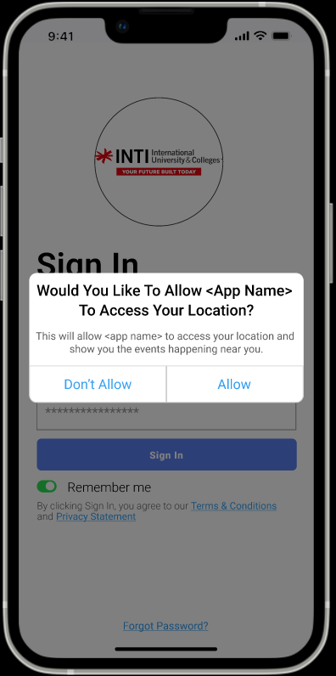

Figure 5

The student has to tap on “Don’t Allow” if he/she does not want to allow the application to access his/her location and allow if he/she wants to allow the application to access his/her location.

The prototype developed is based on the student allowing the application to access his/her location.

If the student taps on “Allow”, the application will navigate to the landing page which is the Home page as shown in Figure 6 below.

If the student taps on “Don’t Allow”, the landing page will be similar to the Home page as shown in Figure 6 except without the Nearby Events feature.

**Method 1 (Through Home page)**

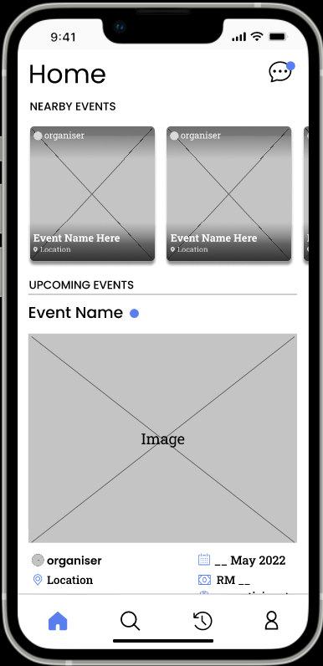

Figure 6

Figure 6 shows the user interface for the Home page.

On this page, the student can horizontally scroll the frames of events below the “Nearby Events” text to view the picture of the events posted by the organizers, the organizers’ profile names, event names, and the location of the events. The events that are displayed in this frame are the events that are held nearby the student currently. The grey rectangle that is crossed is where the image of the event set by the organizer should be.

The student can scroll down the Home page to view the upcoming events. The events shown below the “UPCOMING EVENTS” text are upcoming events that have not been joined by the students.

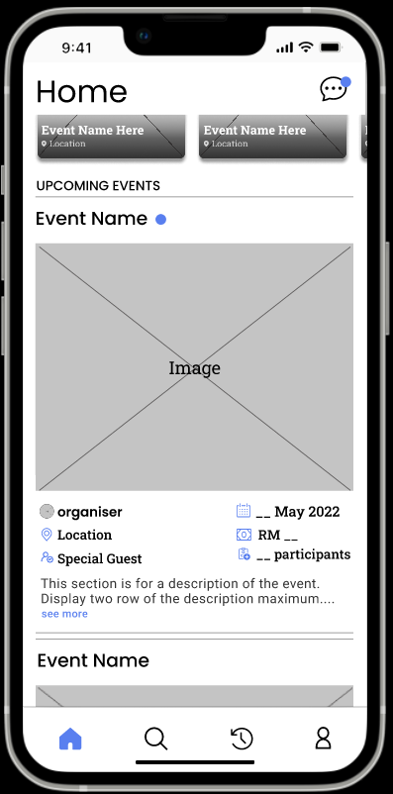

Figure 7

When the student scrolls down the Home page, the student can view the event picture and details of the event as shown in Figure 7.

The “Event Name” text is where the name of the event set by the organizer will be. The grey rectangle which is crossed and has the word Image is where the picture of the event set by the organizer will be. The grey circle which is crossed is a representation of the organizer’s profile picture and the name of the organizer will be displayed next to the circle. Here, the date of event, location of event, names of any special guest of the event, the fees to join the event, number of participants of the event, and the description of the event set by the organizer will be displayed as shown above.

The student can tap on the blue text “see more” to fully display the description on the Home page.

The blue dot next to the “Event Name” text is to indicate whether there are any new updates of the event by the organizer on the event details page (Figure 8). If the student has already seen the new updates about the event, the blue dot will not be there.

The student can tap on the event image for the upcoming events as well as the nearby events to navigate to the events detail page for that event as shown in Figure 8 below.

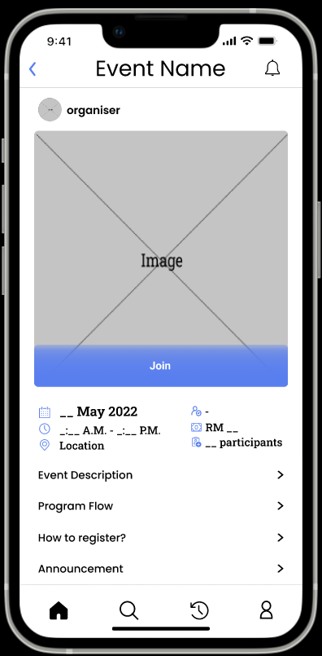 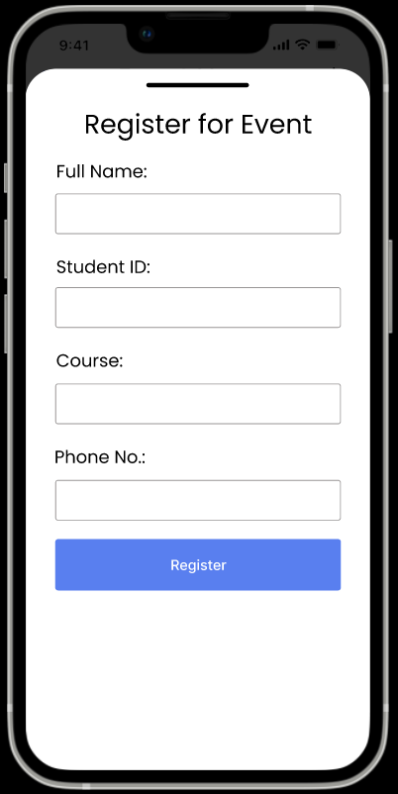

Figure 8 Figure 9

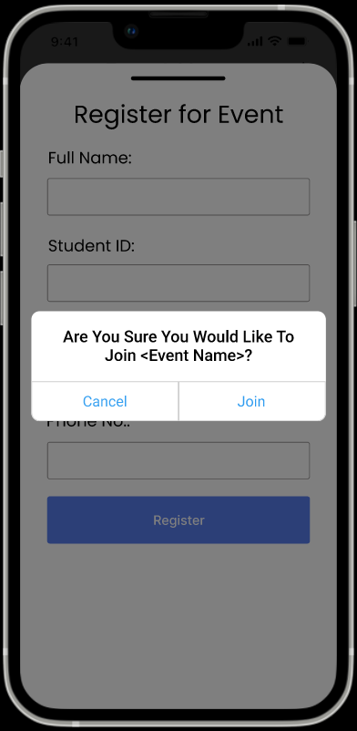 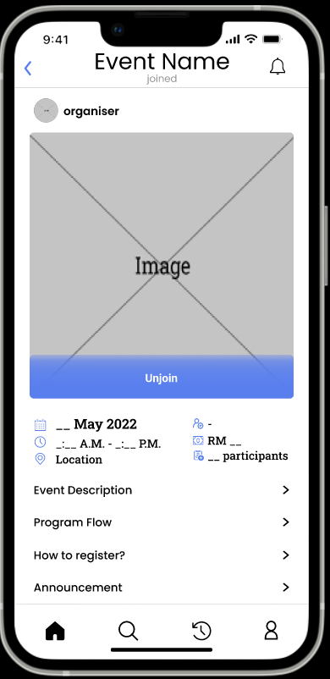

Figure 10 Figure 11

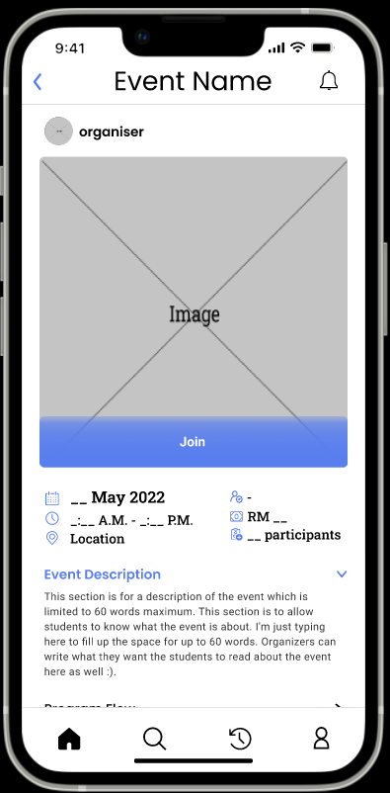 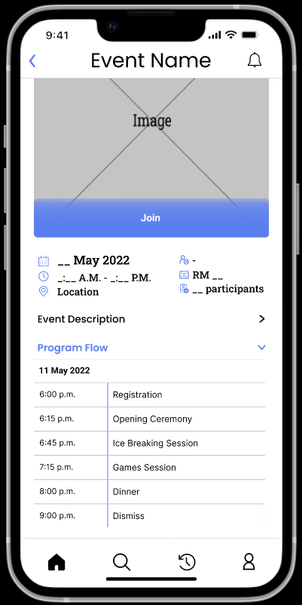

Figure 12 Figure 13

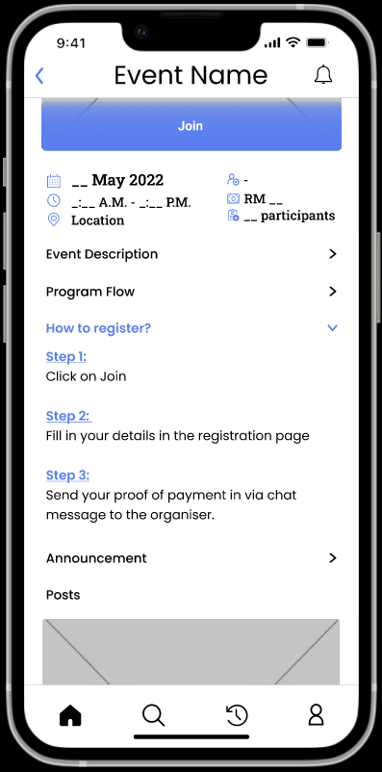 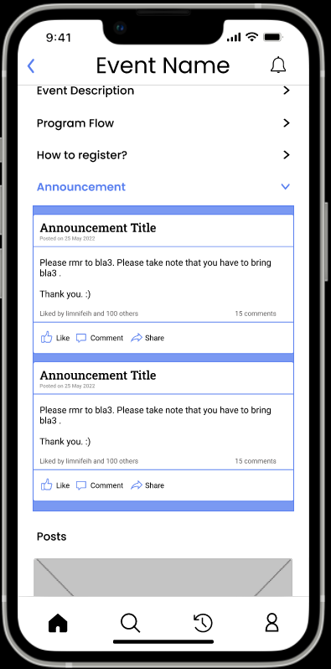

Figure 14 Figure 15

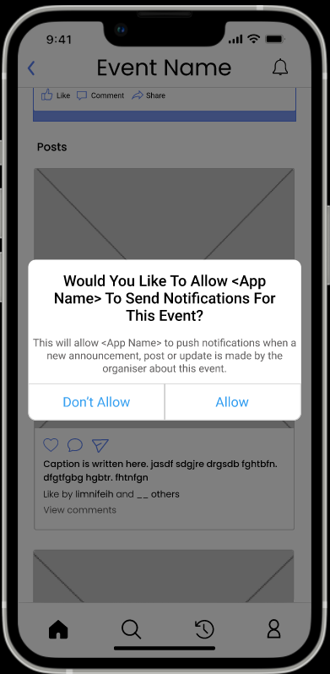

Figure 16

Figure 8 shows the event details page.

Here, the student can see the same information as shown in the Home page. If there is no special guest for the event, there will be a “-“ next to the special guest icon.

To register for the event, the student has to tap on the “Join” button which will open an overlay for the student to input their details as shown in Figure 9. Then, the student has to click on the “Register“ button.

After that, another overlay will pop up for the student to confirm his/her registration for the event as shown in Figure 10. When the user taps on “Join” the application will display the event details page again but this time, there will be a grey “Joined” text displayed below the event name at the top of the page, and an “Unjoin” button on the event image as shown in Figure 11.

Additionally, the student can see the event description, program flow, registration method, announcement, and posts of the event on this page.

The student can tap on the “Event Description”, “Program Flow”, “How to Register?”, or “Announcement” texts to view the contents as shown in Figure 12, Figure 13, Figure 14, and Figure 15 respectively.

The student can like, comment, and share the announcement as well.

If the student wants to receive notifications when there are updates about the event such as new posts, or announcements for the event, he/she can tap on the bell icon located at the top right corner of the page. Then, the overlay shown in Figure 16 will pop up if he/she has not allowed the application to push notifications to his/her device. To allow, he/she has to tap on “Allow”.

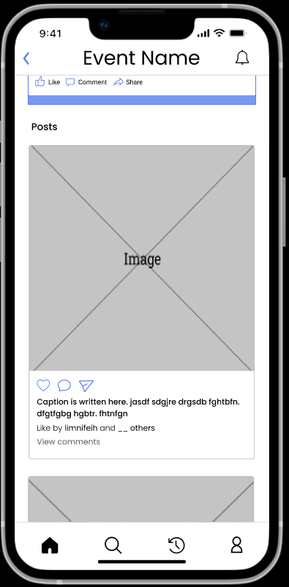

Figure 14

If the student scrolls down the event details page, the student can see the posts along with the captions for the event which are posted by the organizer as shown in Figure 14 above.

The student can like, comment, and share the posts as well.

If the student wants to read the comments for the post, he/she has to tap on the “View comments” text.

**Method 2 (Through Search page)**

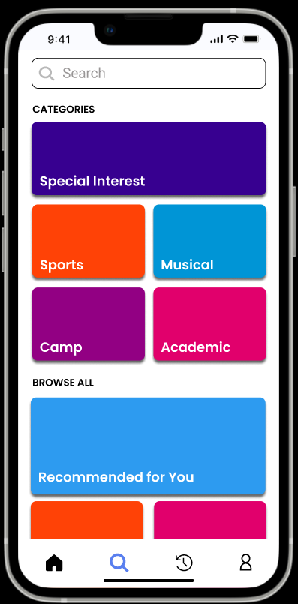

Figure 15

Figure 15 above shows the Search page of the application.

To navigate to this page, the student has to tap on the magnifying glass icon located on the tab bar on the bottom of the screen.

Here, the student has to tap on the text box with grey “Search” text to input the event name. Then, the application will show a list of event names that is the same as the one input by the student. When the user taps on any the event name listed, the application will bring the student to the event details page such as the one shown in Figure 8.

Additionally, the search page has a few boxes with name of the categories of the events. If the student taps on any of those, the application will send the student to a page that will list all the event names that are under the category chosen.

**The link to the prototype of this application is:**

<https://www.figma.com/proto/67V50nTsp9vbmDjZp8LaoK/College-Event-System-App?node-id=401%3A1777&scaling=scale-down&page-id=0%3A1&starting-point-node-id=2%3A2>

# Usability Testing Question

The usability testing questions are asked to know how intuitive the system is to the users to ensure that they have a good user experience when using the application. As the application has never been used by anyone before, pre-test questions are not available for the usability testing question.

The tests are to be done with students as they are the target users for this application. The testing will be carried out by 5 students from any college as the tests carried out after the 5th user are considered a waste of resources according to Nielsan Norman.

## In-test Questions

### Sign in

1. **How do you sign in?**

Reason: To know whether the student can easily sign into the application as the start of using an application being easy is very important. If users do not understand the starting process of using the application, they might not try to use it anymore.

1. **What do you do if you forget your password?**

Reason: This is to ensure that the student knows by instinct what to do when they forget their password so that they do not panic.

1. **How do you find the terms and conditions and the privacy policy of using the application?**

Reason: To make sure that the student knows how to find the terms and conditions and privacy policy of using the application as there is no button for it.

### Home

1. **When you land on the Home page, what is the first thing you do? What motivated you to do so?**

Reason: To identify how students use my app. Are they using it the way I intended, or have they created their own workflows because something is missing? If they use it differently, I can get deep into why they use the app the way they do. This can uncover the suggestions they have to make it better.

1. **What event detail(s) do you think is/are necessary to be displayed on the Home page?**

Reason: To identify what information of the events are most important to the student in helping them decide whether to find out more about the event or not so that they can get the information it from the landing page.

1. **What event detail(s) do you think is/are not necessary to be displayed on the Home page?**

Reason: To identify what information of the events are not important to the student to help them decide whether to find out more about the event or not. This is to reduce redundant information displayed on the landing page to make it as optimal as possible.

1. **What do you do when you want to view all the details of an event from the Home page? Is it better than your expectation? (If no) How would you prefer it to be done?**

Reason: To know how easy the main function on the Home page (view details of events) is to be carried out to the user. This question can also give insight on how to make this function more user friendly.

1. **When you see an event that you are interested in on the Home page, how do you register for it?**

Reason: To identify whether the user can carry out the main function of the system easily as difficult user interface can cause the users to stop using the application altogether.

1. **What do you think about how the information and features are laid out?**

Reason: This question is asked to identify what information and features are suitable for the functions from the users’ perspective. This is due to the Home page containing many available features. Thus, it is important to ensure that the users can find what they need easily.

### Event Details Page

1. **What are your thoughts on the layout and design of this page?**

Reason: As the event details page is one of the most important and intended to be one of the most used page in the application, it is important to make sure that the users are comfortable with the layout and design of this page.

1. **Do you like the interface? Is it easy to use? Which part of the interface do you like/dislike?**

Reason: As the event details page is one of the most important and intend to be most used page in the application, it is important to make sure that the users are comfortable with and enjoy using the user interface of this page.

1. **How do you turn on notifications when new details are uploaded about the event?**

Reason: To make sure the users instinctively know how to turn on the notifications for the event they are interested in as this is a function that is estimated most users will use. It is important that users can easily carry out functions of the application so that it does not stop them from using the application.

### Chat

1. **How do you navigate to the chat page?**

Reason: As the application does not allow the users to navigate to the chat page straight away through the tab bar, the time taken to access the chat page might be a too long or the task might be too tedious for the users.

1. **What do you do when you want to chat with someone who is not listed on the chat page?**

Reason: On this page, one of the most important feature is to chat with someone who the user has never chatted with before. This question is asked to ensure that the users can easily find and use the feature.

1. **How do you block someone from chatting with you?**

Reason: To improve the experience of the user on the application and protect the user from potential threats such as stalkers, the user is allowed to block other users from chatting with him/her or viewing his/her profile. This question is asked to make sure the user knows how to use this feature.

1. **How do you report someone?**

Reason: To improve the experience of the user on the application and allow the user to report other users who are abusing or not abiding by the terms and conditions of using the application, the user can report the offender. This question is asked to make sure the user knows how to use this feature as it is an important function to protect the users’ well-being.

### Search

1. **What do you expect to be able to search on this page?**

Reason: This question is asked to know the expectations of the user so that I can know how in line the system is with the user’s expectations and make updates in the future according to the expectations of the user where appropriate to include.

1. **What other event categories or details categorization should be added here?**

Reason: This question is asked to collect data on how to ease the search function for the users where they can just tap on the category displayed on the search page instead of typing to find the results. Repetitive answers received by the user can be added into the system improve the user’s experience.

### Joined Events

1. **How do you rate events that you have joined?**

Reason: To test how long the time taken to rate the event is and ensure it does not take too long or the task might be too tedious for the users.

1. **How can you unjoin an event?**

Reason: To test how long the time taken to unjoin an event is and ensure it does not take too long or the task might be too tedious for the users which can stop users from using the application altogether.

### Organizer Profile

1. **How do you navigate to an organizer’s profile?**

Reason: As the application does not allow the users to navigate to the organizer’s profile page straight away through the tab bar. This question is asked to test how long the user take to find an organizer’s profile page and discuss possible solutions to reduce the process for better user’s experience.

1. **What do you do if you want to block an organizer?**

Reason: To improve the experience of the user on the application and protect the user from potential threats such as stalkers, the user is allowed to block organizers from chatting with him/her or viewing his/her profile. This question is asked to make sure the user knows how to use this feature when needed.

1. **What can you do if you want to receive notifications when an organizer organizes a new event?**

Reason: This question is asked to ensure the user knows how to activate this feature. Updates can be made for this feature if many users do not know how to.

### Profile

1. **What other things would you like to be able to edit in settings?**

Reason: This open-ended question is aimed to receive feedbacks on what the user would like to customize in the application to improve the user experience.

1. **How do you log out of your account?**

Reason: This question is asked to see where the user expects the log out function is located and see how in line the current process is to the user and discuss on which process is better and the better option can be implemented into the system.

## Post-test Questions

1. **What parts of the application do you use the most? Why?**

Reason: This question is to figure out what matters to the users so that I can get insights into what the majority of the users find most useful in the application. This can be a guide for future updates on the application to be more in line with the users’ preferences.

1. **What parts of the application do you use the least? Why?**

Reason: This will tell me what users do not like and can do without in the application. The responses will be an opportunity to get feedback on how to make those parts of the platform better.

1. **If you could change one thing about this app, what would it be? Why?**

Reason: The insights I get from this question will help me make changes to almost every part of the system.

1. **Overall, how has your experience been with the application?**

Reason: This question gives the user the option freely share insights that haven’t come up in the in-text questioning. Follow-up questions will be asked based on what they share.

1. **Will you continue to use this application? What will stop you from using this application in the future?**

Reason: This question helps me pinpoint exactly what makes the user most satisfied with the platform and identify what causes them frustration. The drawbacks of the application can be revisited and updated based on the feedbacks.